Problem 1

A) Variable x is an int, not a pointer, so it cannot be set to a memory location.

B) The statement should be 'ptr = &x;' because ptr has already been initialized as a pointer, having the '\*' again is incorrect.

C) The statement should be 'cout << \*(numbers + 3) << endl;' because otherwise it would print 13, since \*numbers automatically returns the first value in the array, and the +3 would just add 3 to that value.

F) The statement should be '\*iptr \*= 2;' because we are changing the value the pointer points to, not the pointer itself.

I) The statement should be 'val \*= 2' because val is not a pointer, so it can be directly manipulated.

M) This would return the address of wholeNum rather than the value of wholeNum.

Problem 2 Results: 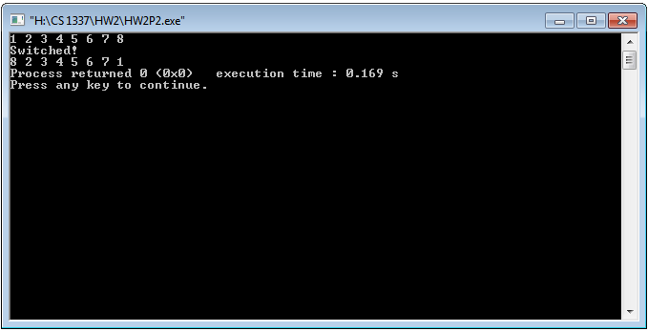

Problem 3 Results: